QUIZZ {1h00}

STUDENT FIRST NAME / LAST NAME: 

**WARNING**

**YOU NEED TO CHECK CAREFULLY STEP BY STEP THAT YOUR CODE WORKS**

**If you code does not work, you will get a 0 score**

**Exercise 1: (25 POINTS)**

|  |  |
| --- | --- |
| Objective | Pick up all diamonds |
| Maximum number of instructions | 10 |
| Allowed instructions | GO-UP GO-DOWN GO-LEFT GO-RIGHT PICK-UP  IF  REPEAT N-TIME WHILE |
| Allowed conditions | <HAS DIAMOND> |

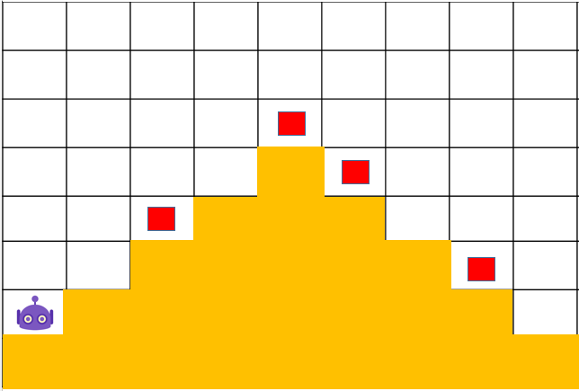

Go down

Go right

Pick up

Has diamond

while

Repeat 4

Go right

Go up

Pick up

Has diamond

while

Repeat 4

**Exercise 2: (25 POINTS)**

|  |  |
| --- | --- |
| Objective | Pick up all diamonds |
| Maximum number of instructions | 14 |
| Allowed instructions | GO-UP GO-DOWN GO-LEFT GO-RIGHT PICK-UP  IF  REPEAT N-TIME WHILE |
| Allowed conditions | <HAS DIAMOND> |

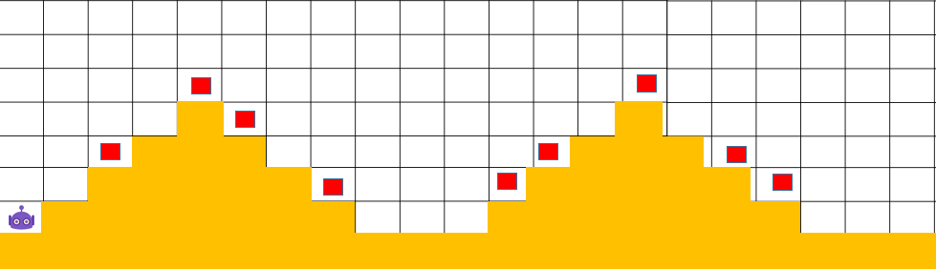

Repeat 2

**Exercise 3: (25 POINTS)**

Repeat 3

Go right

while

Repeat 4

Repeat 4

while

Has diamond

Pick up

Go up

Go right

Has diamond

Pick up

Go right

Go down

|  |  |
| --- | --- |
| Objective | Bring all carrots to their respective box |
| Maximum number of instructions | 13 |
| Allowed instructions | GO-UP GO-DOWN GO-LEFT GO-RIGHT PICK-UP DROP  IF  REPEAT N-TIME WHILE |
| Allowed conditions | <HAS CARROT> |

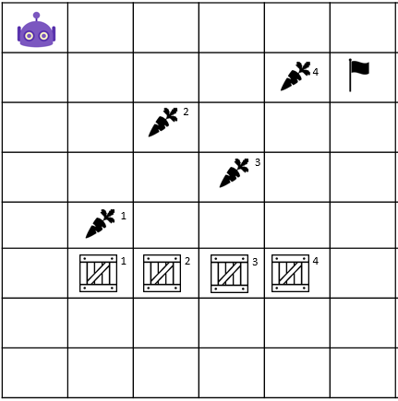

Go down

Pick up

If <has carrot>

Repeat 4

Repeat 4

Go right

Go down

drop

Go right

Repeat 4

Go up

**Exercise 4: (25 POINTS)**

* Flag**:** ទង់ជាតិ

|  |  |
| --- | --- |
| Objective | Bring all carrot to their respective box **and** stop at the flag!!  WARNING : you program must work for the 2 cases !!! |
| Maximum number of instructions | 10 |
| Allowed instructions | GO-UP GO-DOWN GO-LEFT GO-RIGHT PICK-UP DROP  IF  REPEAT N-TIME WHILE |
| Allowed conditions | <HAS CARROT>  <HAS FLAG>  <HAS **NO** FLAG> |

CASE 1 CASE 2

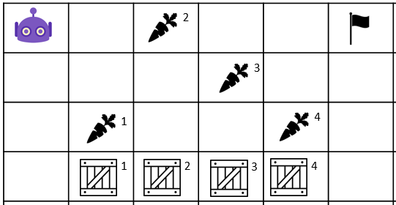 Go 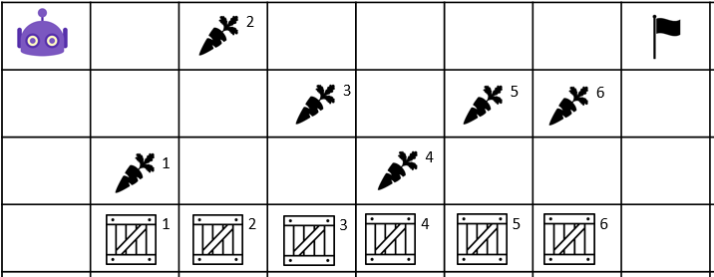

Go right

while <has no flag>

IF <has carrot>

Pick up

Go down

Go down

drop

Go up

Repeat 3

Go right